Spare part list 

RP 300

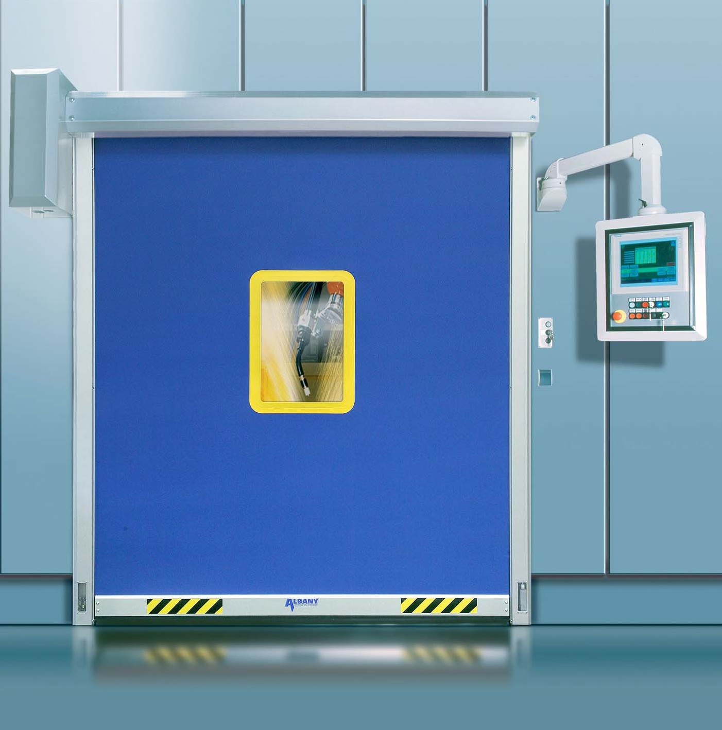

2013-05 Index 00

1 / 7

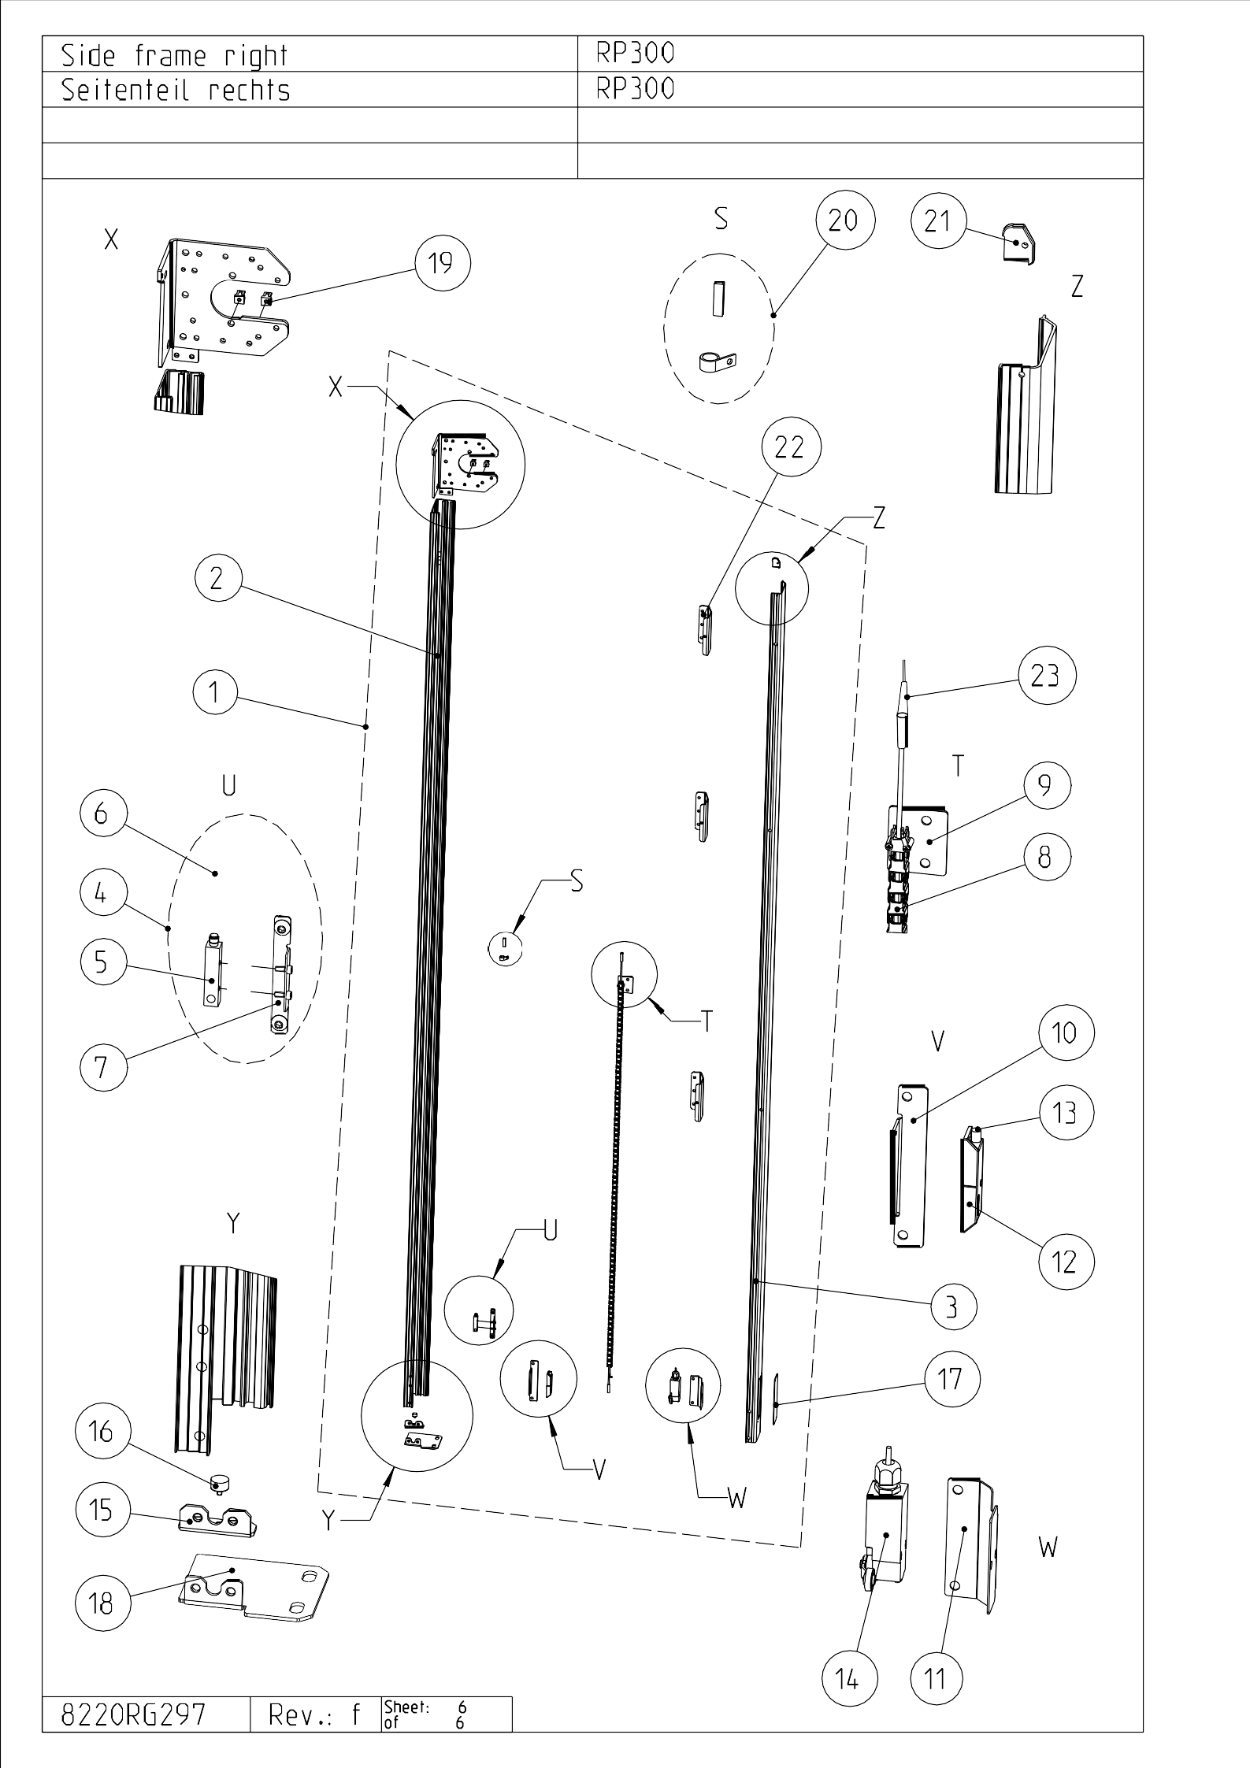

  RP300, Version 09 |  |  | gültig ab ► gültig bis valid from ► valid to |  |  |  | Quantity per door | Verschleißteil Wear part / Slitdetalj
Pos.  Item | Description | Note | gültig ab ► gültig bis valid from ► valid to | Part No | 1 | Unit | Quantity per door | Verschleißteil Wear part / Slitdetalj
I | Side frame right
4 | Photocell cpl transm./rec. with 2 cables |  |  | D8470R0021 |  | Stck./pc. | 1
8
8 | Cable chain f. pre-run. photocell cpl, L=1900mm | DH>2500 |  | D8520R0006 |  | Stck./pc. | 2
12 | Magnet sensor Schmersal | Schmersal |  | D4905R0222 |  | Stck./pc. | 1 | X

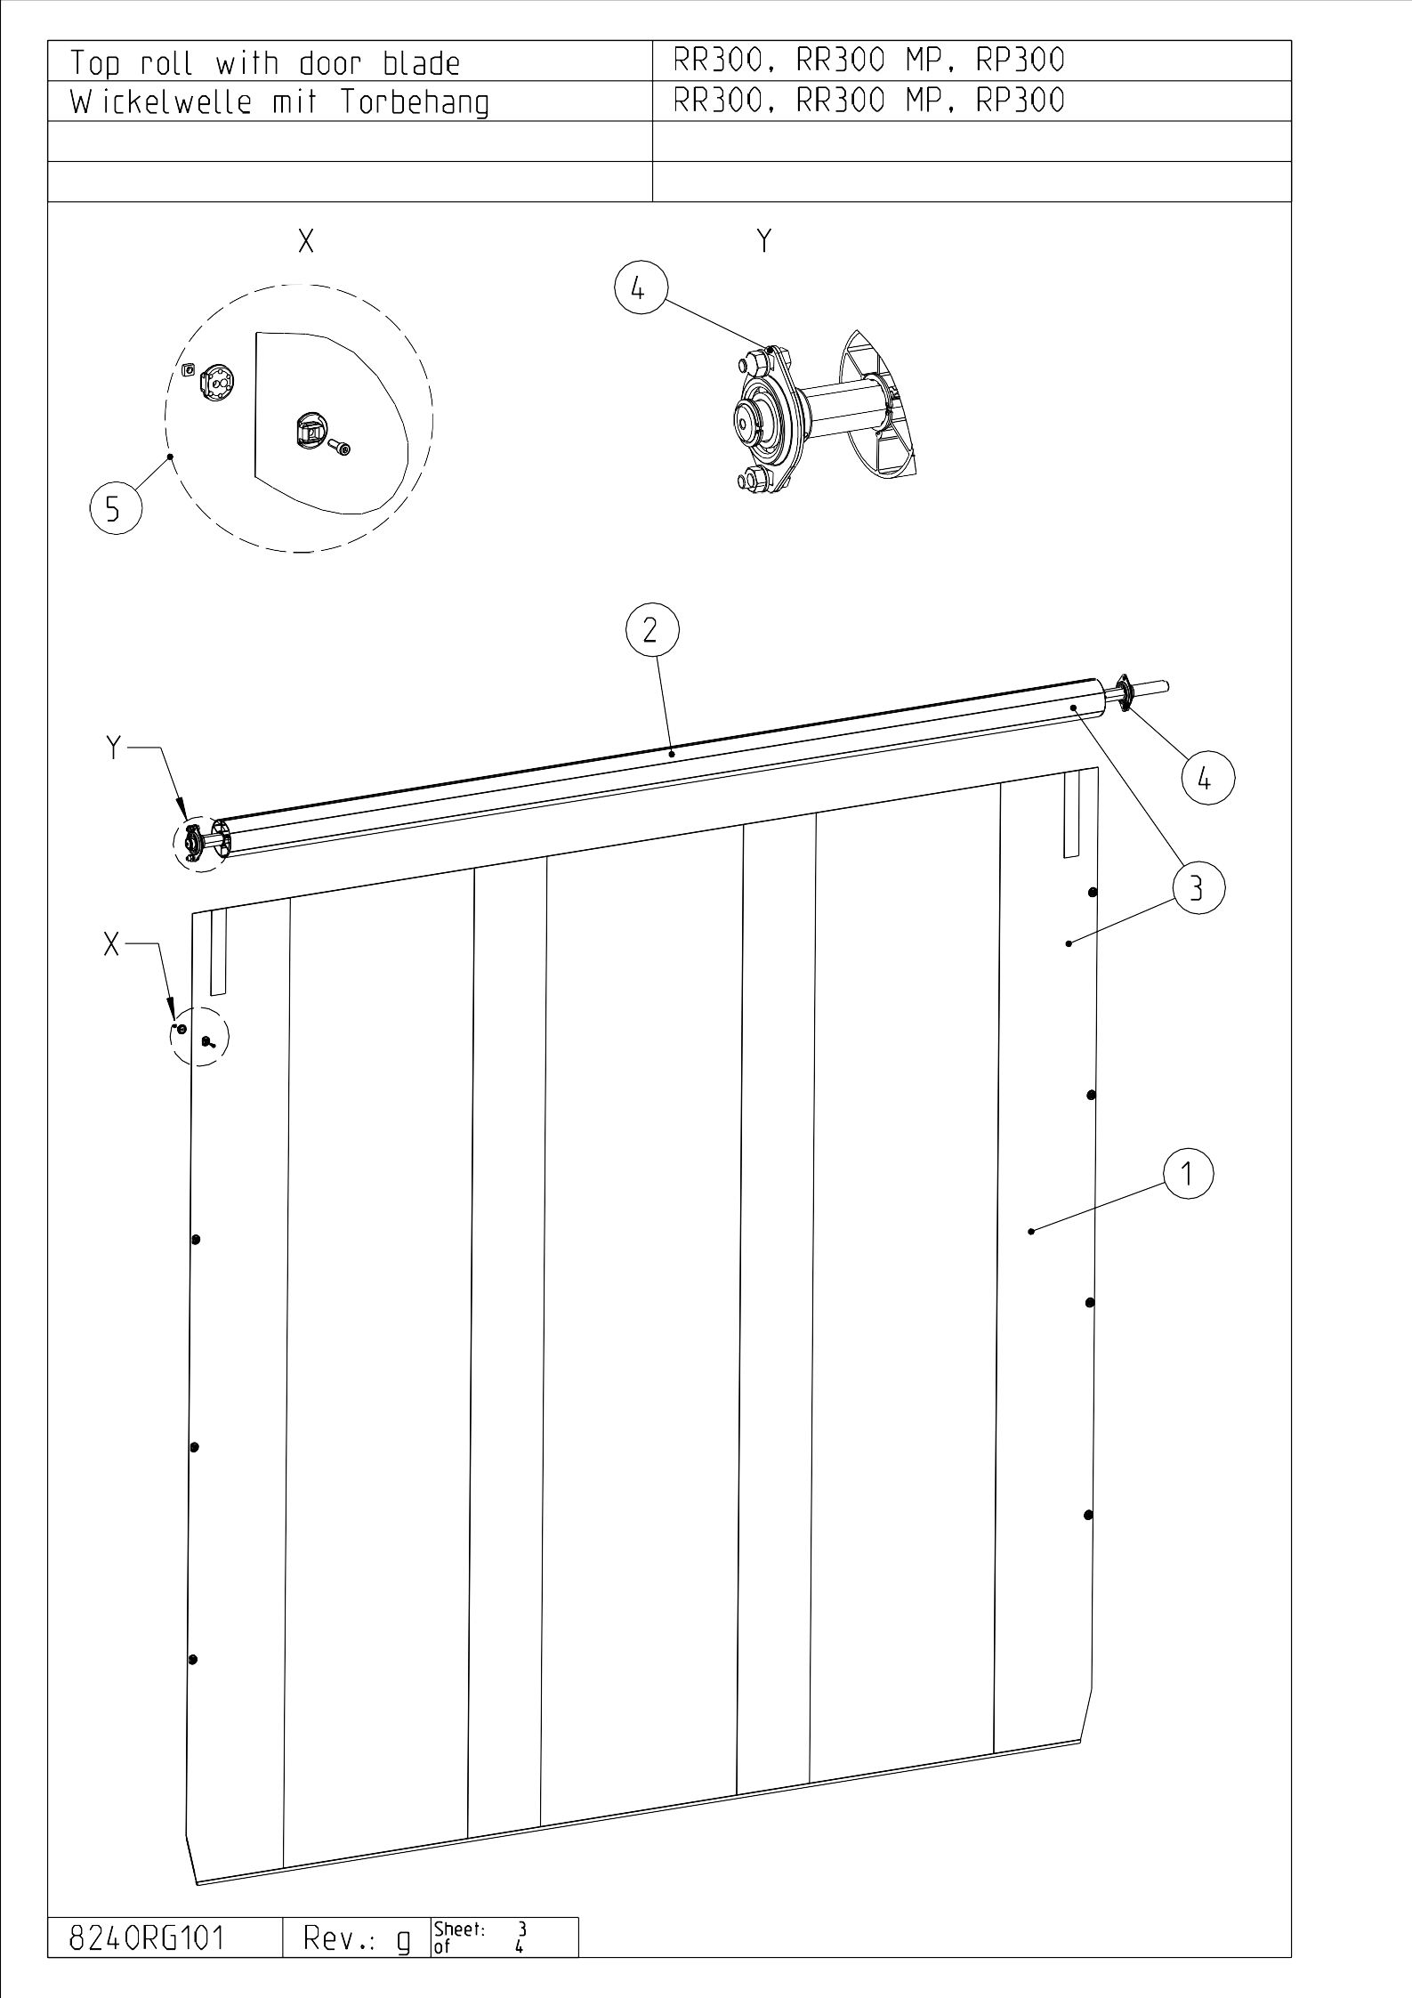

RP300, Version 09 |  |  | gültig ab ► gültig bis valid from ► valid to |  |  |  | Quantity per door | Verschleißteil Wear part / Slitdetalj
Pos.  Item | Description | Bemerkung  Note | gültig ab ► gültig bis valid from ► valid to | Item-No | 1 | Einheit  Unit | Quantity per door | Verschleißteil Wear part / Slitdetalj
III | Top roll / curtain
5 | Windbreaktap (12 pcs) |  |  | D8130R0009 |  | Stck./pc. | 4 | X

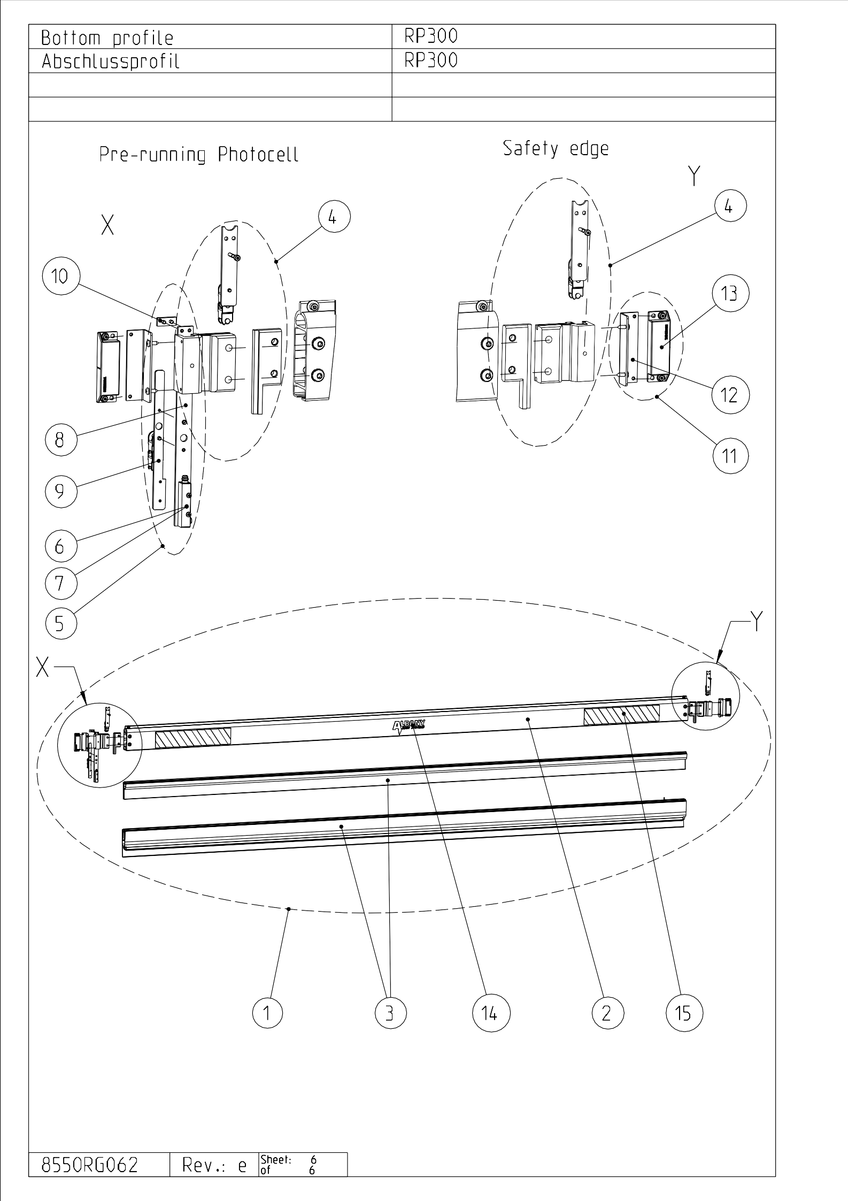

RP300, Version 09 |  |  | gültig ab ► gültig bis valid from ► valid to |  |  |  | Quantity per door | Verschleißteil Wear part / Slitdetalj
Pos.  Item | Description | Bemerkung  Note | gültig ab ► gültig bis valid from ► valid to | Art.-Nr.  Item-No | 1 | Einheit  Unit | Quantity per door | Verschleißteil Wear part / Slitdetalj
IV | Bottom profile
3 | Rubber profile with integrated safety edge |  |  | D4421RG036 | G | m | 1
 |  |  |  |  |  |  |  | X
 |  |  |  |  |  |  | 1
6 | Safety photocell transmitter - red | LH (**) | - 2011-08  just in pair 2011-09 ►  also single | D4904R0544 |  | Stck./pc. | 1
7 | Safety photocell receiver - yellow | RH (**) | - 2011-08  just in pair 2011-09 ►  also single | D4904R0545 |  | Stck./pc. | 1
13 | Magnet | Schmersal |  | D4905R0223 |  | Stck./pc. | max 2

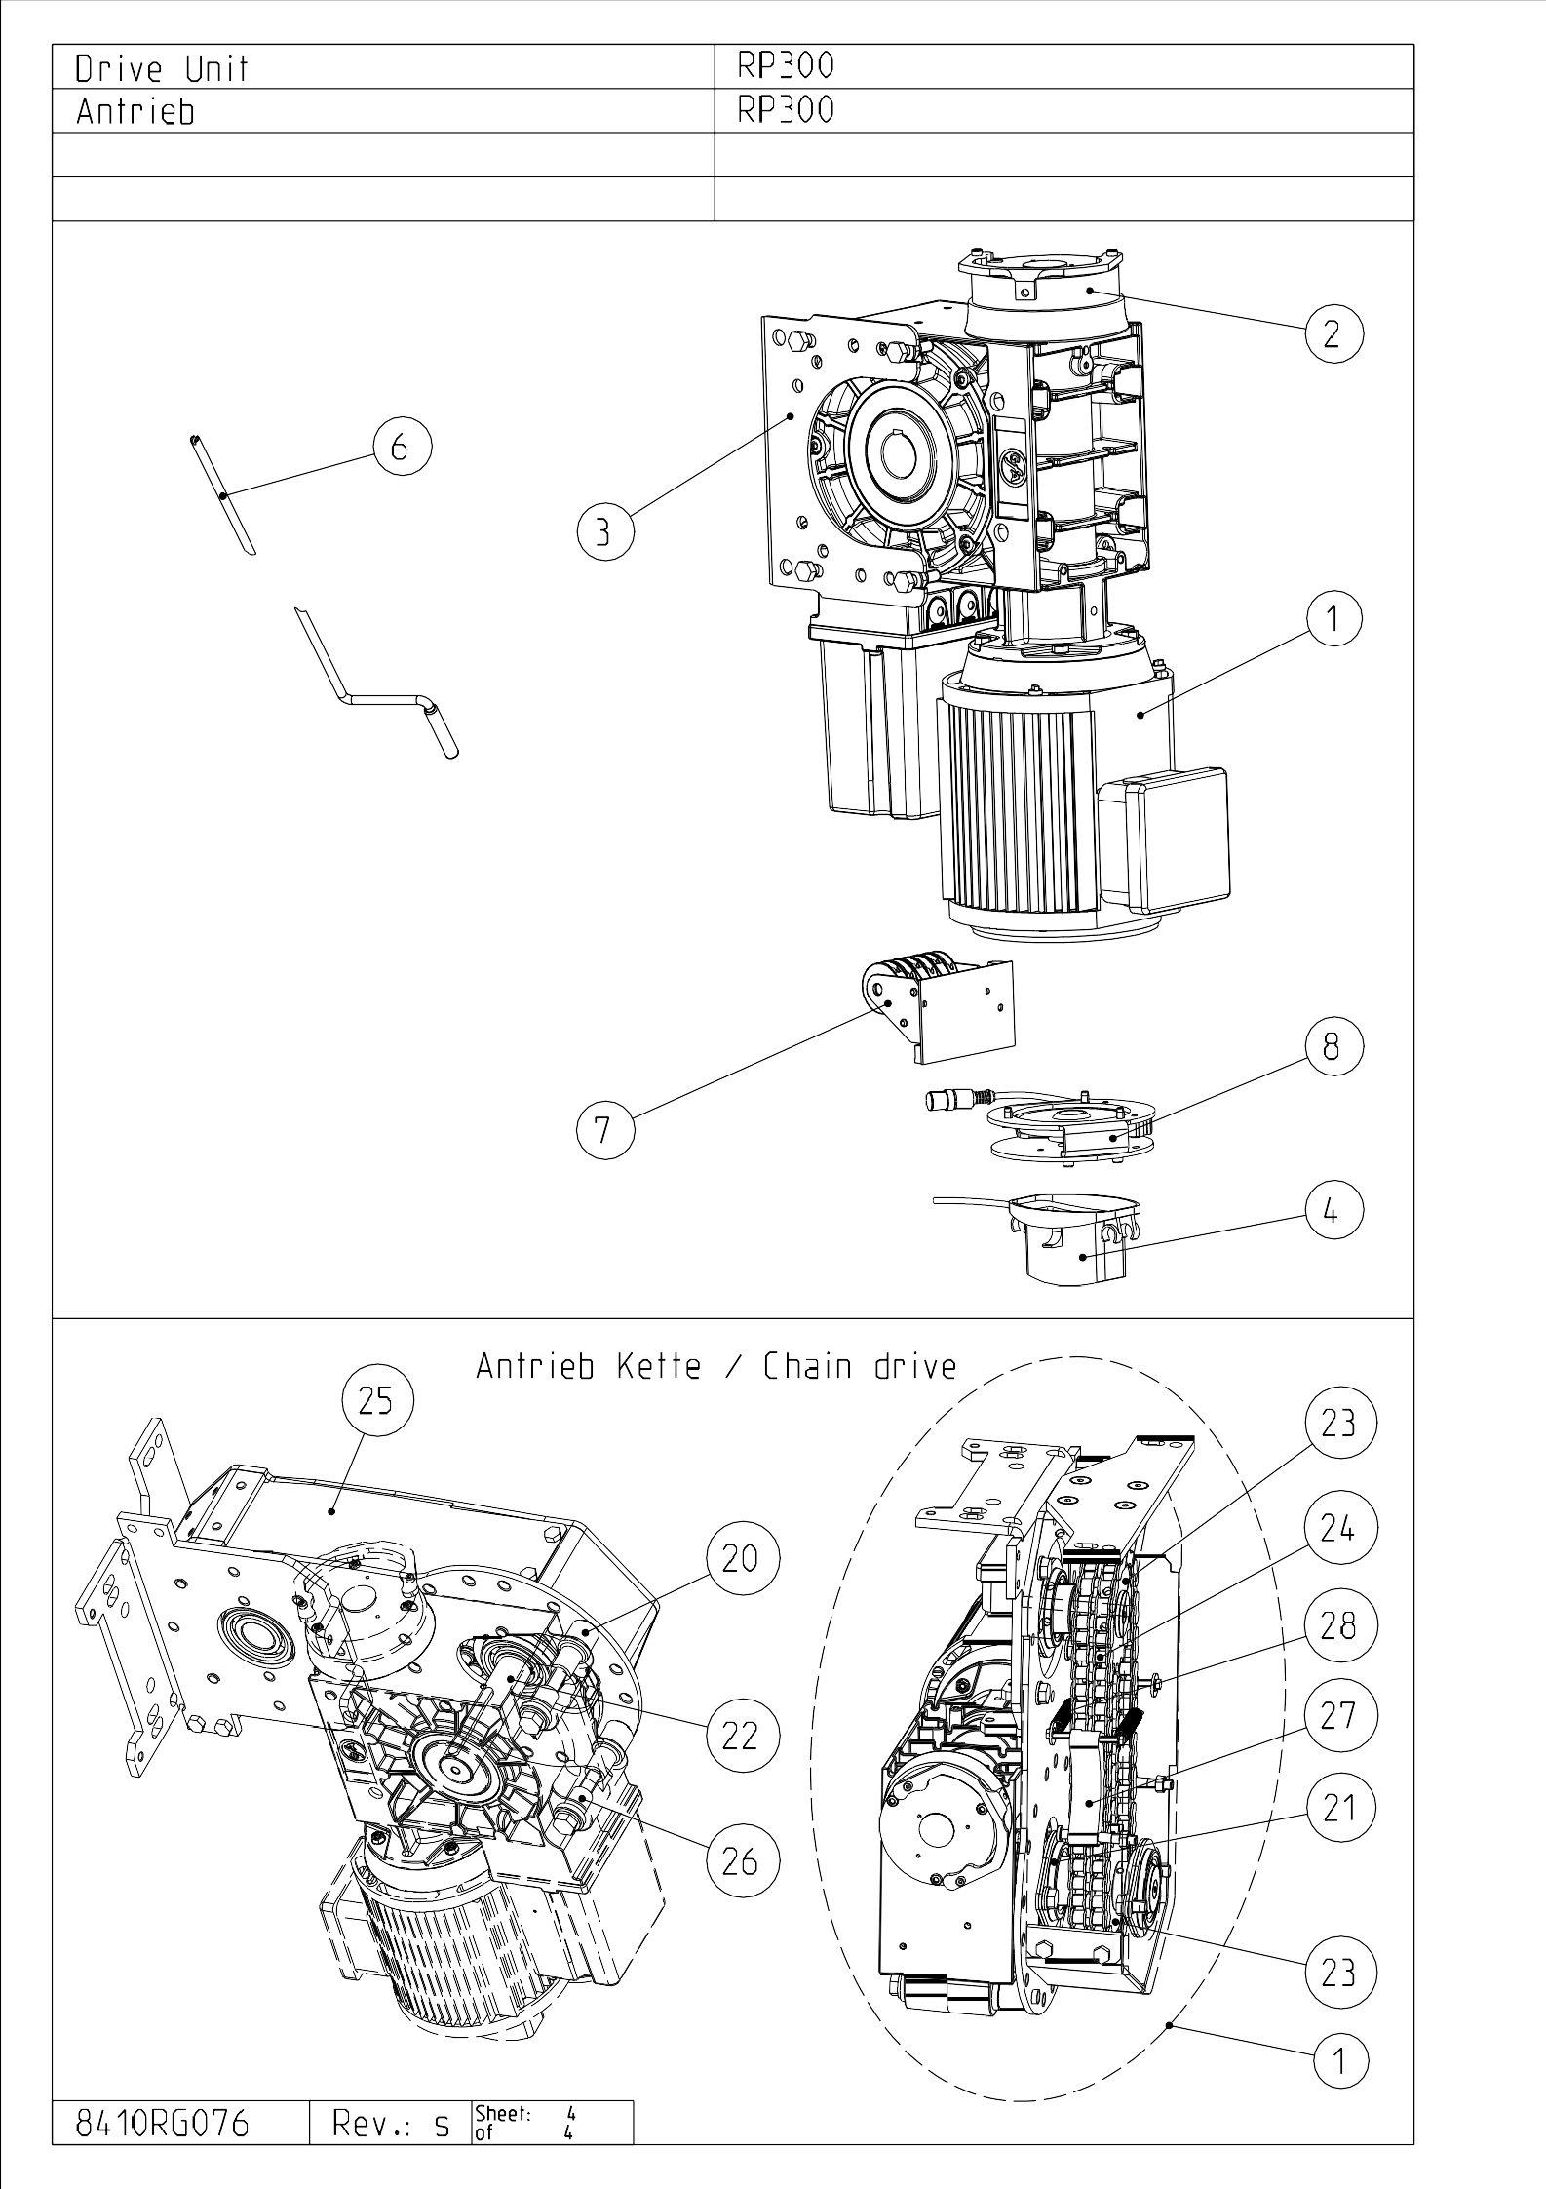

4 / 7

RP300, Version 09 |  |  | gültig ab ► gültig bis valid from ► valid to |  |  |  | Quantity per door | Verschleißteil Wear part / Slitdetalj
Pos.  Item | Description | Bemerkung  Note | gültig ab ► gültig bis valid from ► valid to | Art.-Nr.  Item-No | 1 | Einheit  Unit | Quantity per door | Verschleißteil Wear part / Slitdetalj
VI | Drive unit
1 | Drive unit cpl GfA | ACS50,  without control |  | D8910R0091 |  | Stck./pc. | 1
2 | Brake GfA |  |  | D6622R0026 |  | Stck./pc. | 1 | X
7 | Limit switch section, 6 switches |  |  | D4905018 |  | Stck./pc. | 1
7 |  |  |  |  |  |  | 6

